**ASSIGNMENT - 01**

**Question 1:**

**Objective:** To learn about Amazon/Google cloud. Use Public cloud computing platforms and learn their virtual computing platform that allows users to rent virtual machines on which they can run their applications.

**Title:** Getting Started in the Public Cloud Computing Platform like AWS/Google.

**Task:** Create AWS instances,Connecting to Your Linux Instance Using SSH and Run a Linux OS in a Virtual Machine .Explore its Computing and Storage.

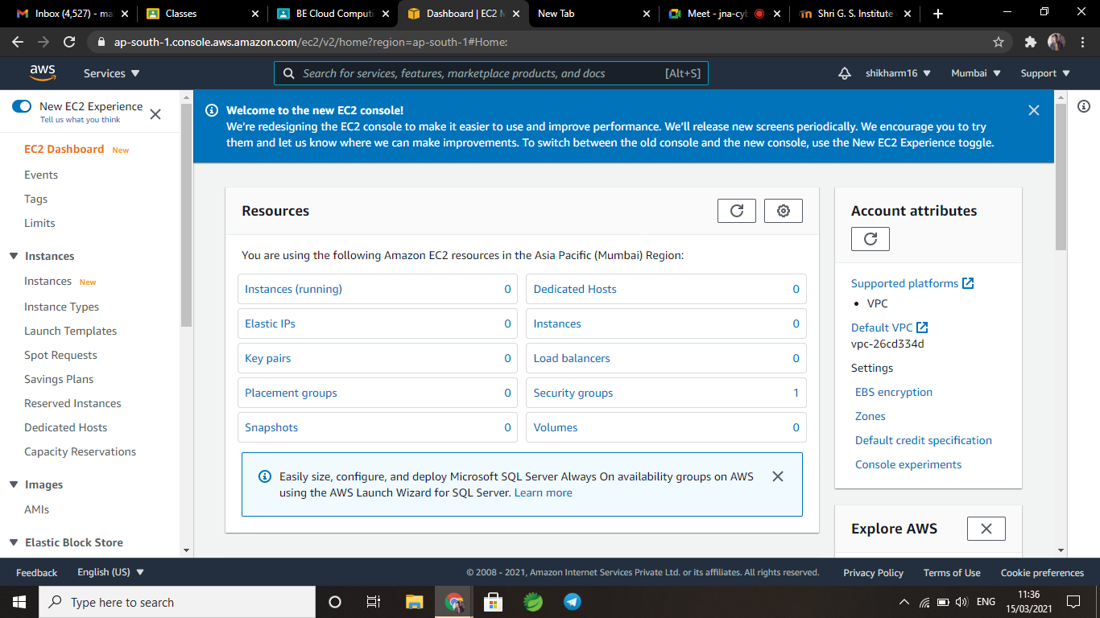

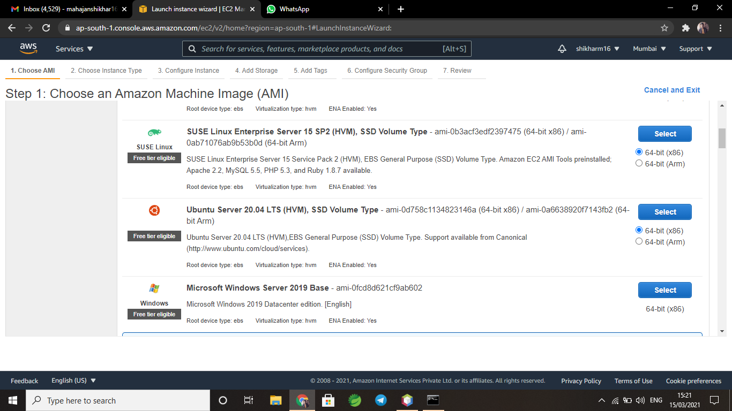

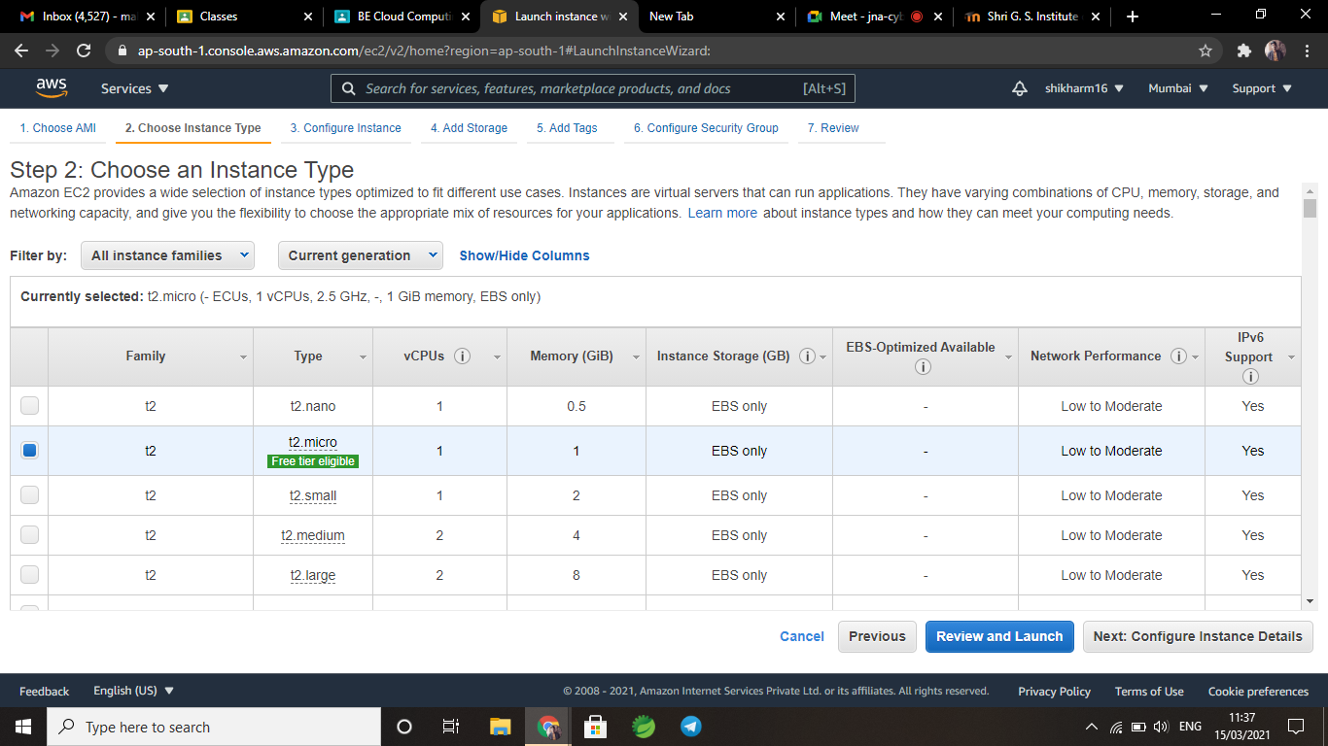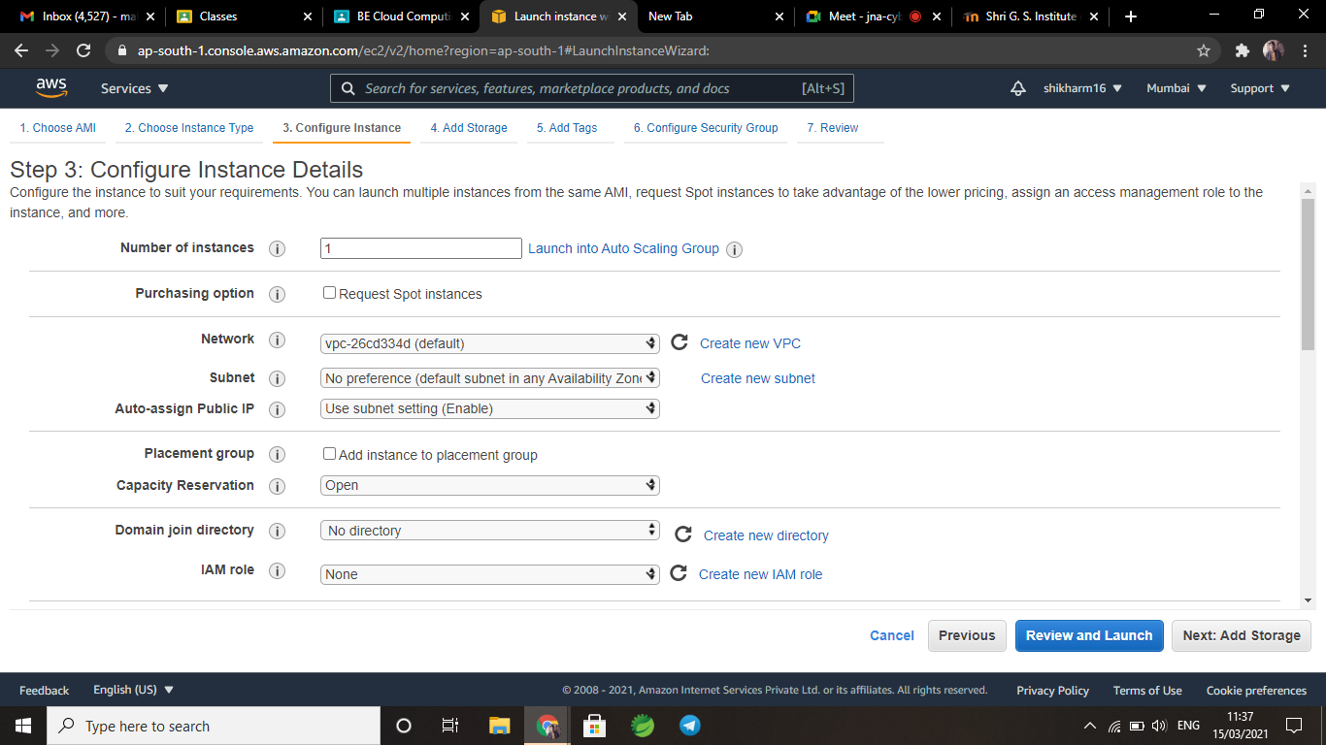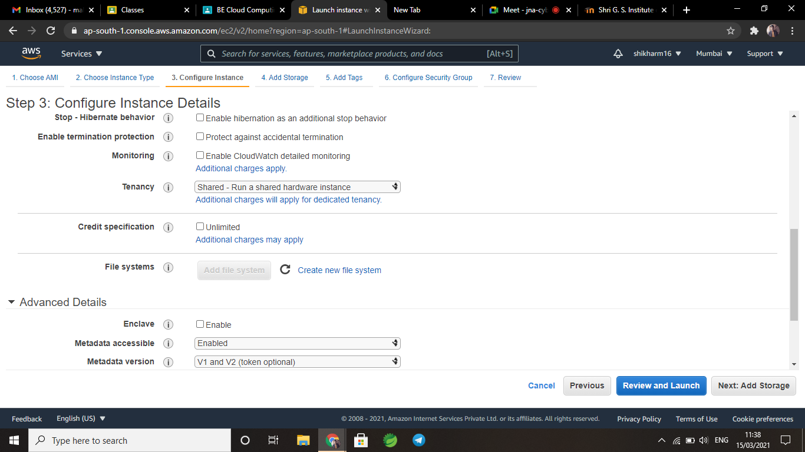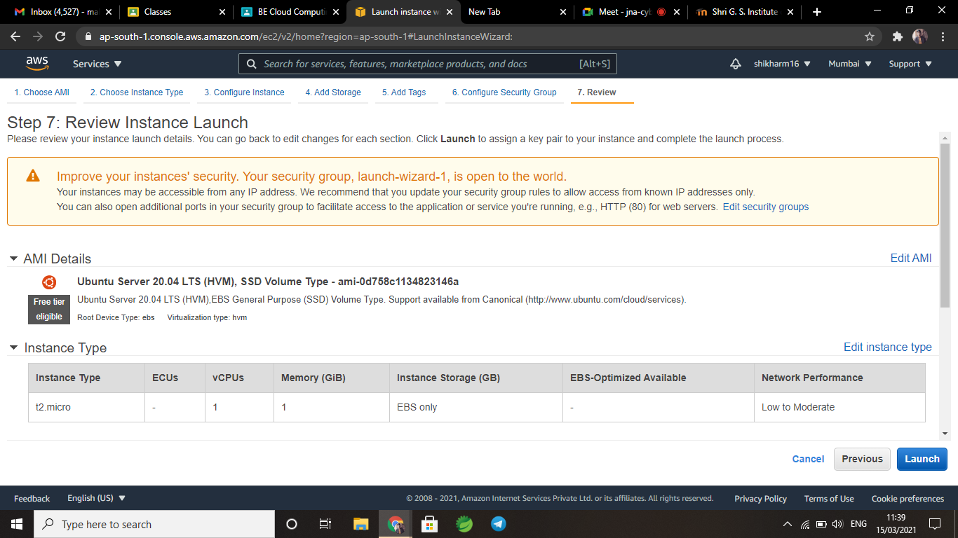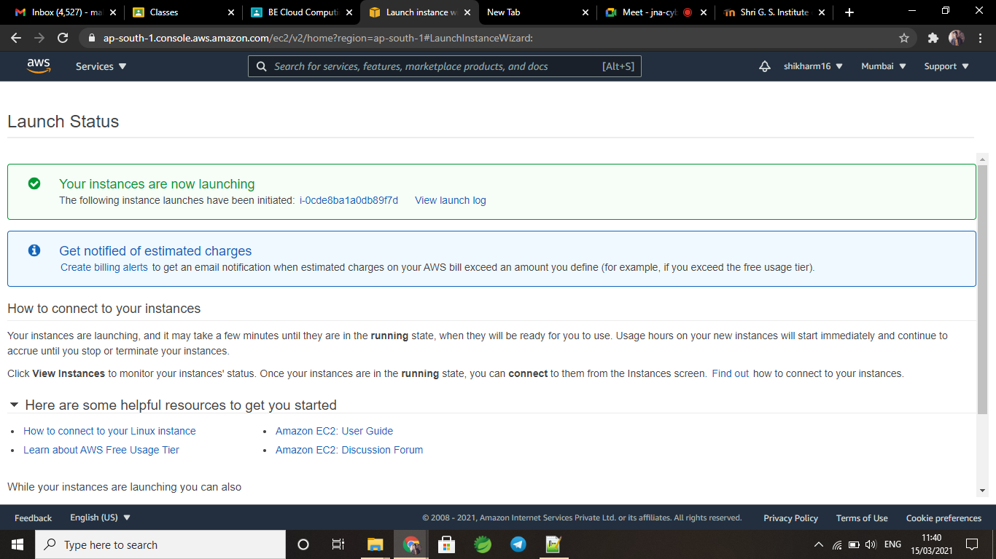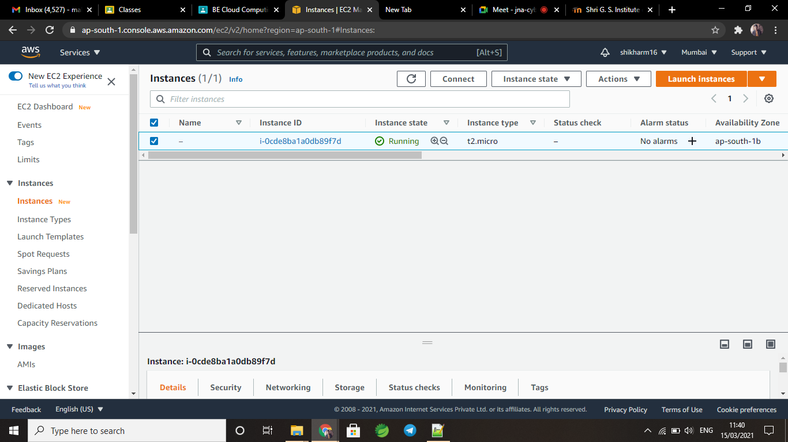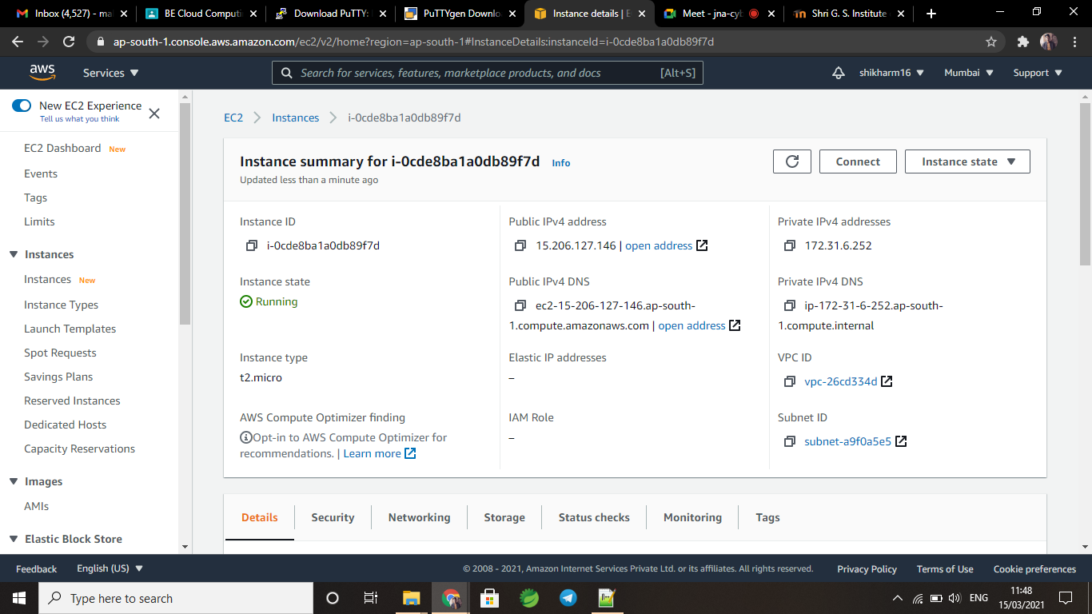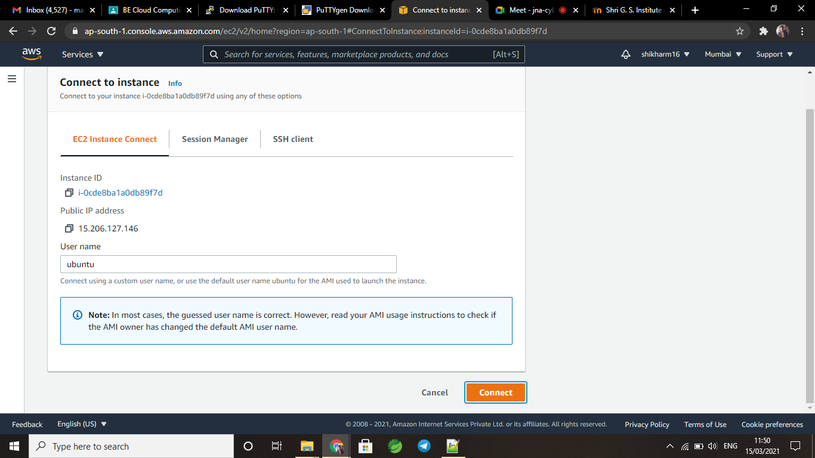

**Question 2**

**Objective:** To learn HDFS commands and design Map Reduce Algorithms.

**Title**: Explore HDFS and design Map Reduce algorithm.

**Task:** Write Map reduce code for some basic problems like word count problem.

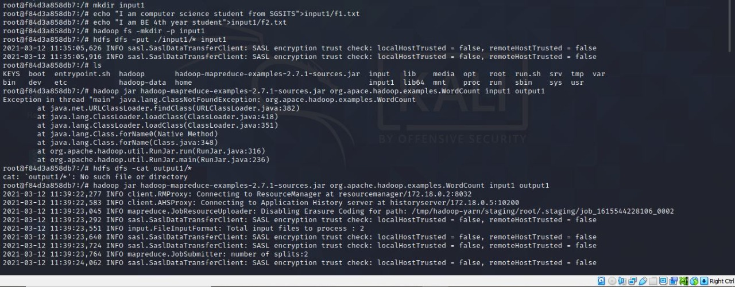

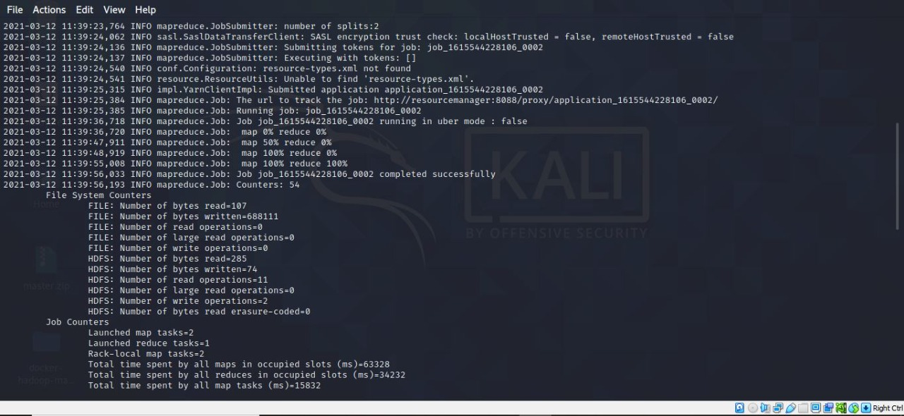

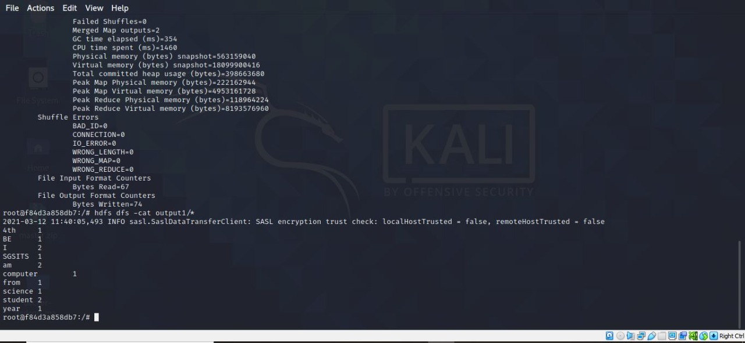

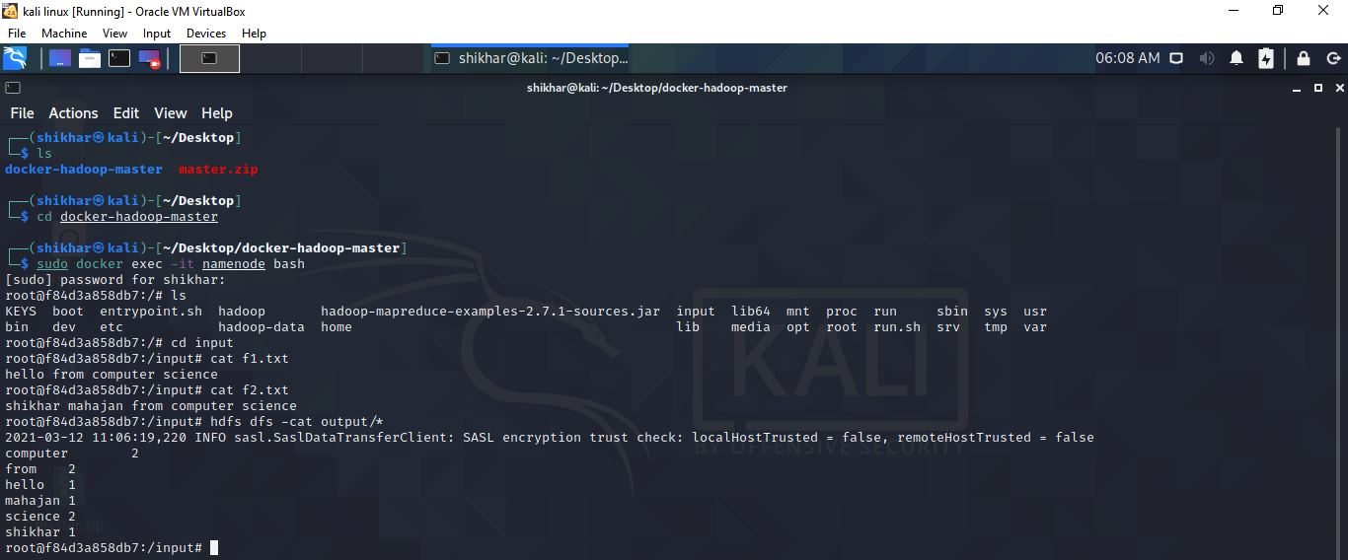

**Question 3 :**

**Objective:** To learn basic Task scheduling algorithms in the cloud .

**Title:** Implement cloud Task Scheduling algorithm using cloud simulator.

**Task:** Install cloudsim and implement basic task scheduling algorithm.

1. **Round Robin**

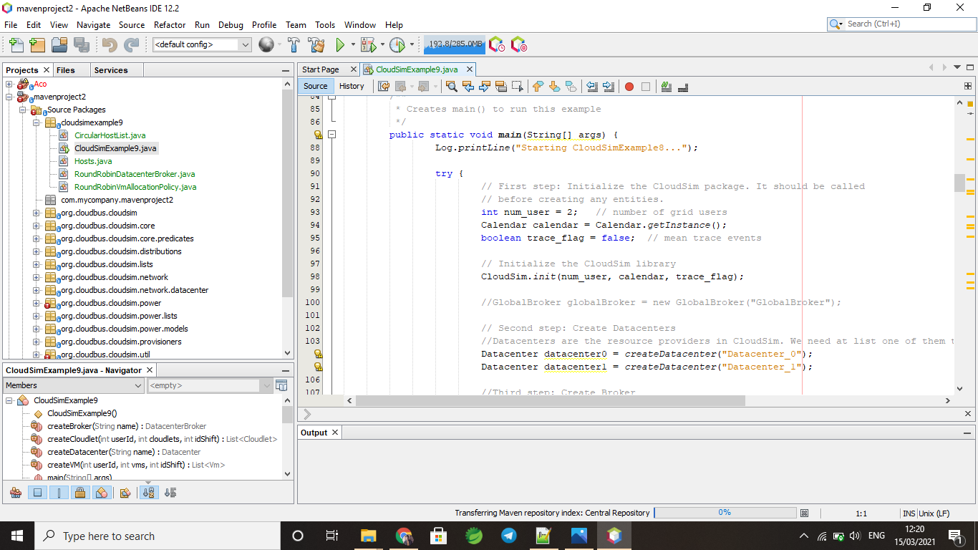

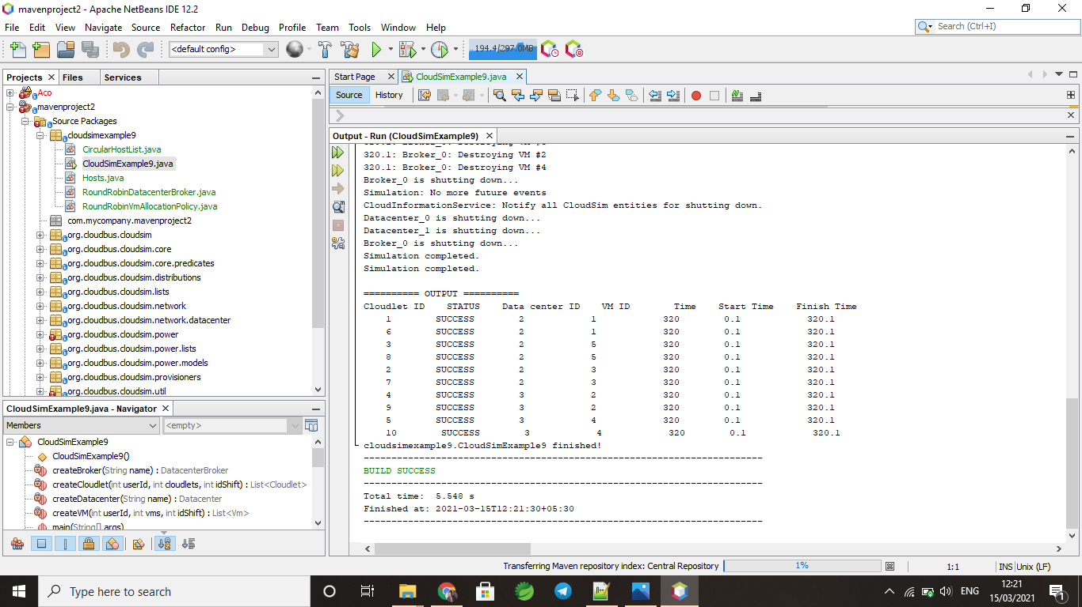

1. **Priority Scheduling**

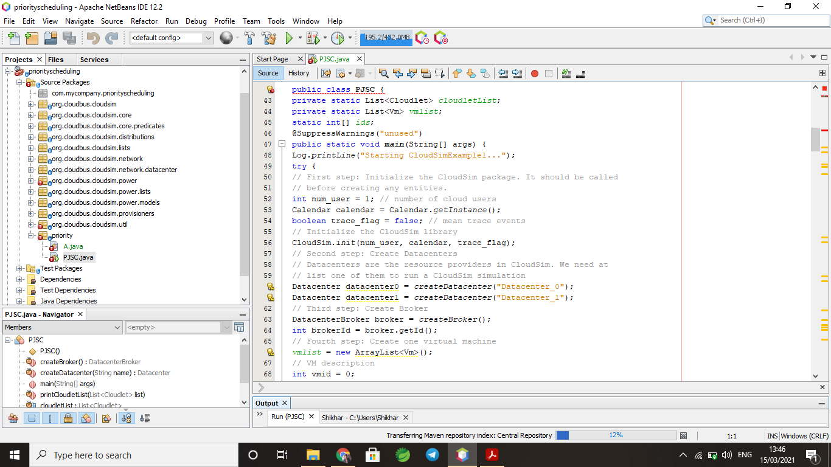

**Question 4:**

**Objective :**To learn use and design of REST APIs

**Title:** Designing a web application that uses REST API's .

**Task:** Design any application that uses the REST interface in json

format and xml format.

REST-API in **python** using **django framework**

Project Name: CloudRest

Two files were used:

1. **Views.py :** Here functionality of api is coded.
2. **Urls.py** : Url of api is mentioned.

Two **GET METHOD** url are their:

**“/”** - Home url , prints hello world as http response

**“Login”** - JSON response url where user data is printed (data is hardcoded)

Server port: http://127.0.0.1:8000/

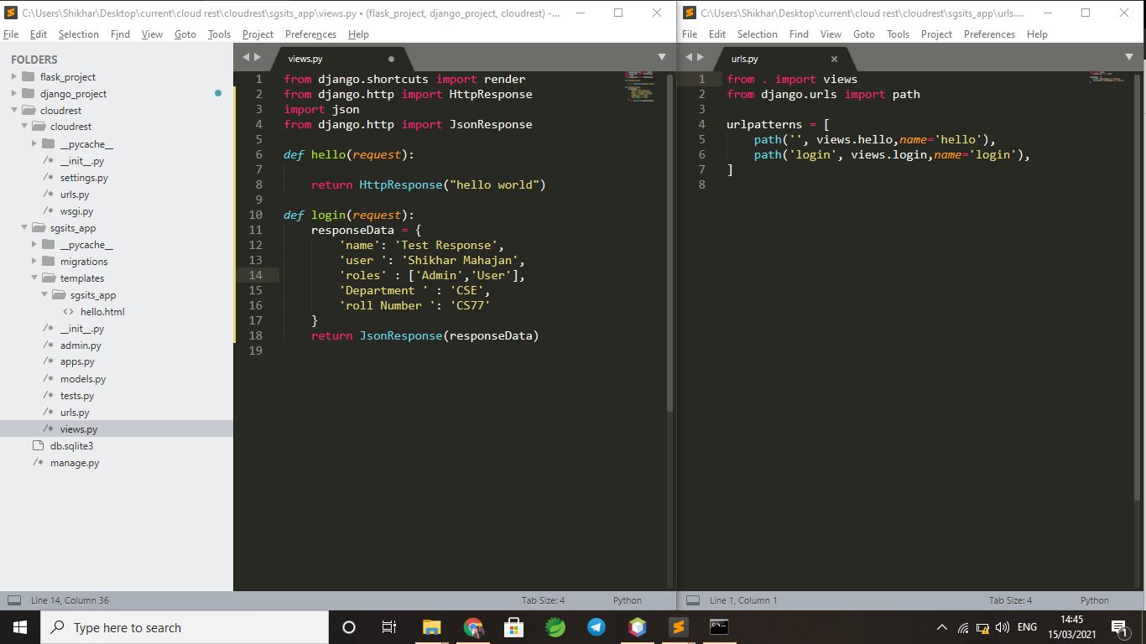

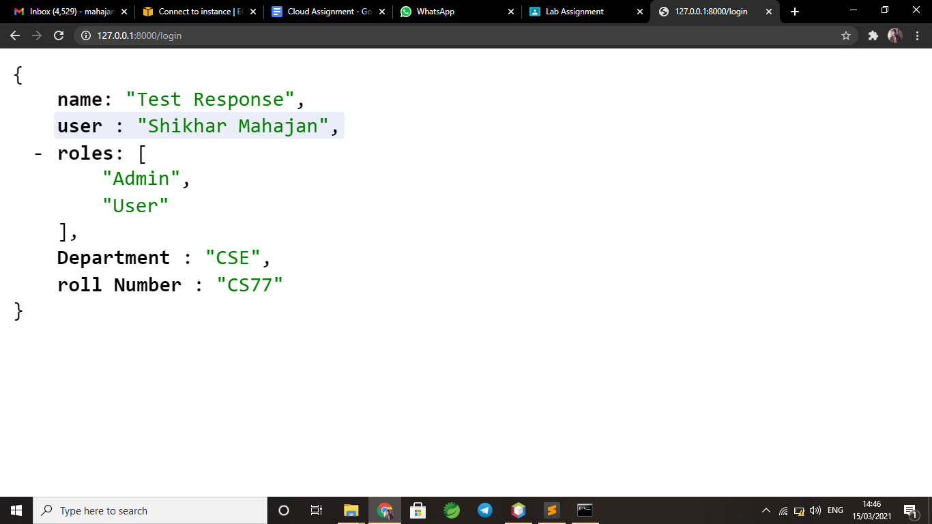

**Question 6:**

**Objective:** To learn Task Optimization in cloud environment

**Title:** Explore workflow simulator and run workflow application

redesign the code with some optimization algorithm like ACO,PSO.

1. **ACO**

**Description ACO:**

Ant Colony Optimization (ACO) was first used by M. Dorigo et al. to solve discrete optimization problems, in the late 1980s. ACO is based on the behavior of ants for finding food. Ants deposit pheromone as they walk and find their route by walking along the pheromone deposition. Density of pheromone deposition increases as ants walk back to the source with food. Pheromone deposition on the way back is dependent on quality and quantity of food taken to the source point. Pheromone deposition /evaporation is directly related to the number of ants traveling on that path. Ants find the optimal path by following maximum pheromone deposition

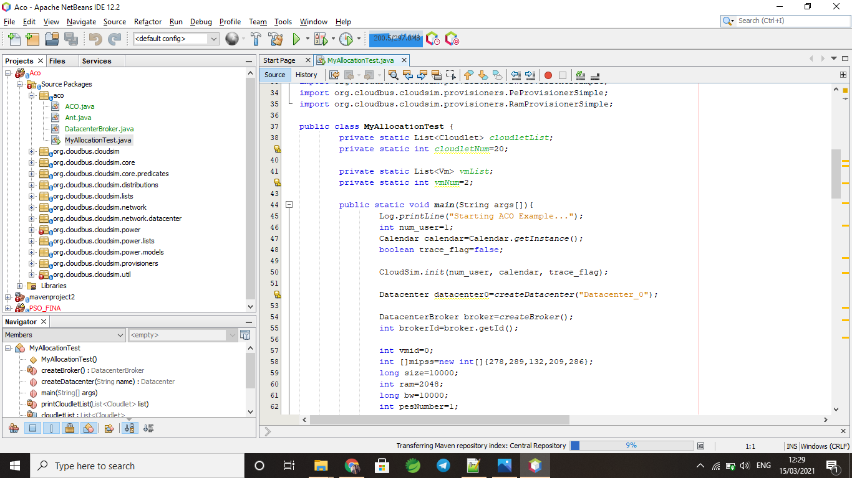

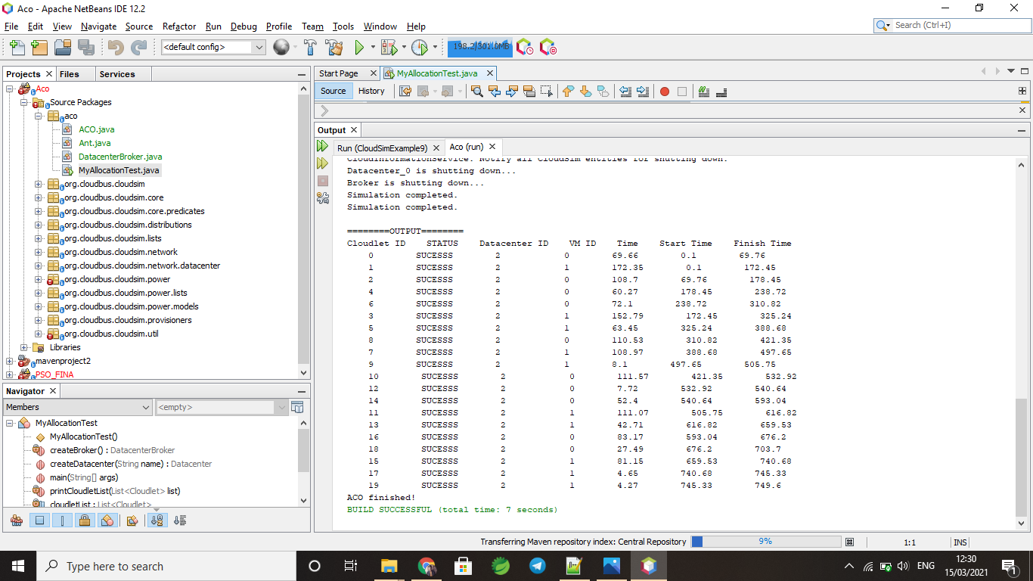

1. **PSO**

**Description PSO:**

PSO is a heuristic global optimization technique. Particle swarm optimization (PSO), originally developed by Kennedy and Eberhart. In PSO each possible solution is called particle and the group of these possible solutions is called population. PSO is based on how a group of birds will randomly search for food. Birds don’t know where exactly the food is, so they follow the bird which is nearest to the food. Each bird is known as a particle and each particle has its fitness function (here it is square of error). A group of particles is known as swarm. In each iteration, first the best solution found in the swarm is stored and is known as pbest. Another best solution is also stored, which is the best solution found so far. Values of pbest and gbest are updated.

